PRACTICAL-3

1. Describe deposit, branch.

Input:

describe Deposit;

Output:

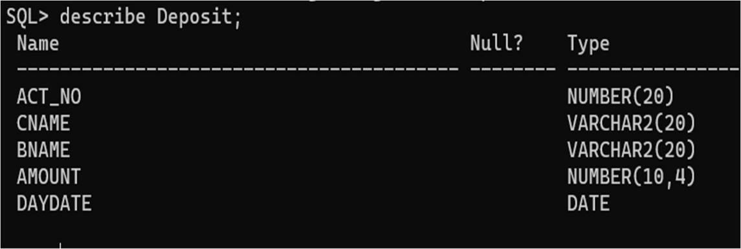

Input:

describe Branch;

Output:

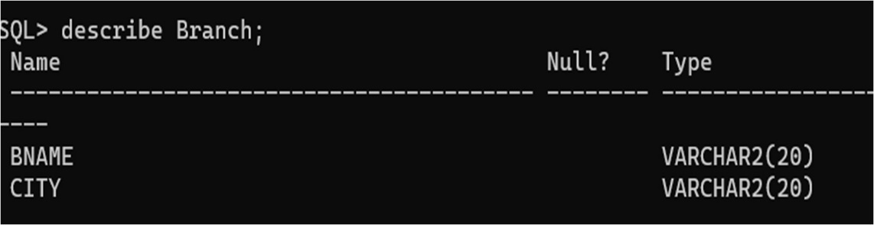

2. Describe borrow, customers.

Input:

describe Borrow;

Output:

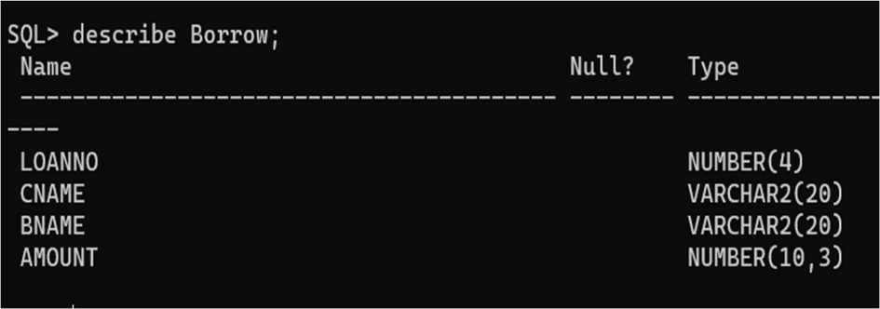

Input:

describe Customers;

Output:

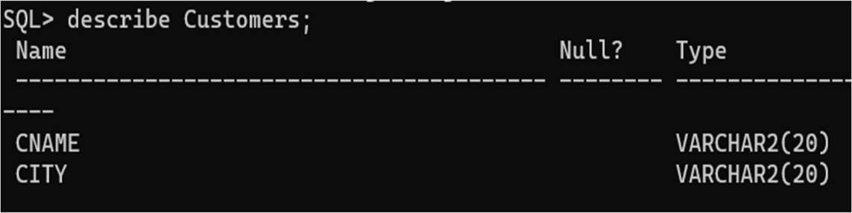

3. List all data from table Deposit

Input:

select *from Deposit;

Output:

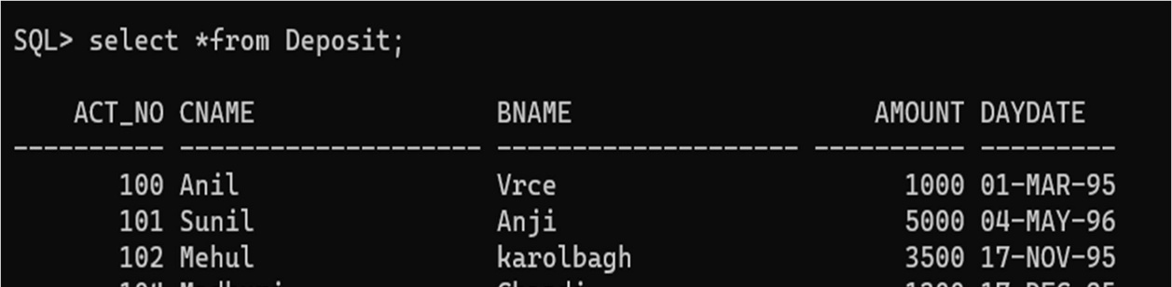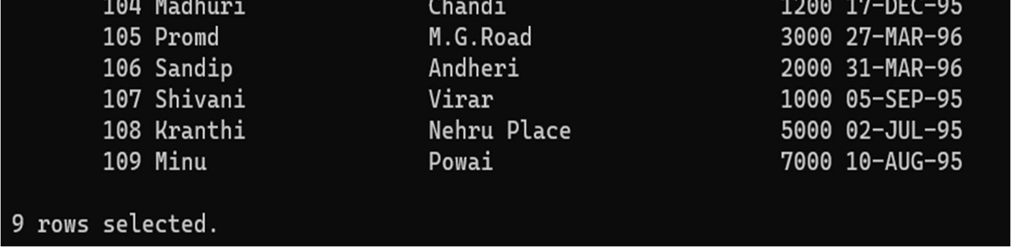

4. List all data from table Borrow.

Input:

select *from Borrow;

Output:

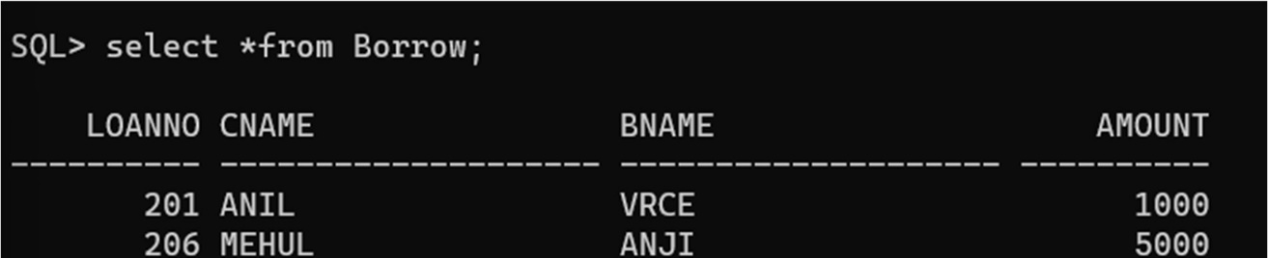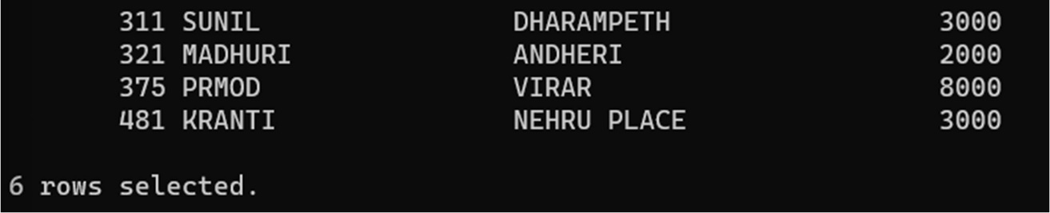

5. List all data from Customers.

Input:

select *from Customers;

Output:

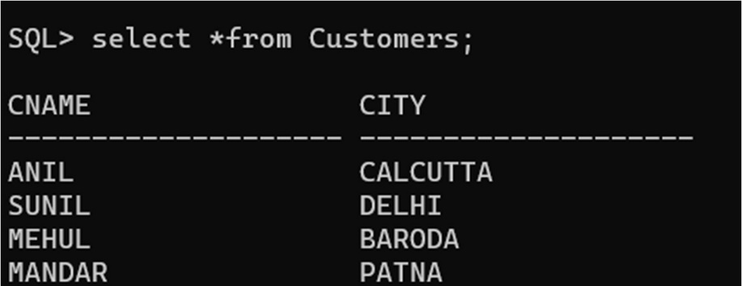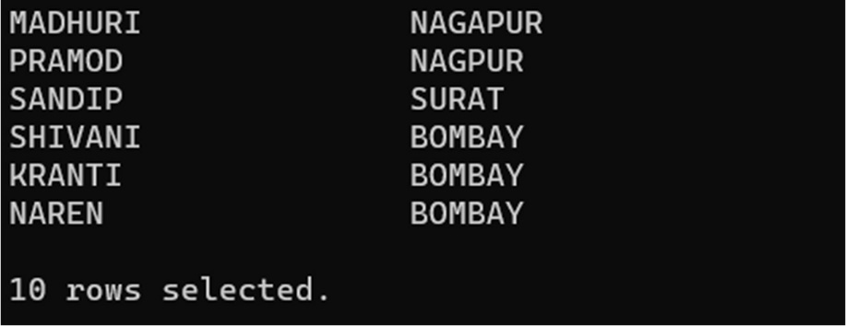

6. List all data from table Branch.

Input:

select *from Branch;

Output:

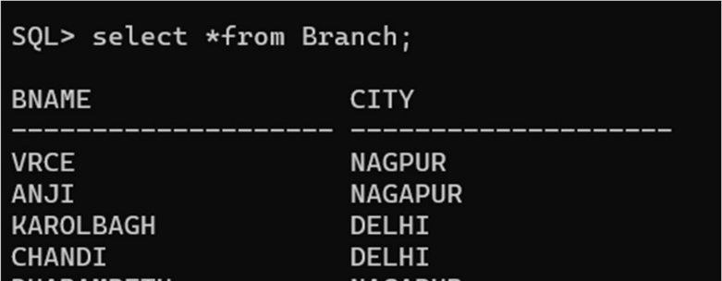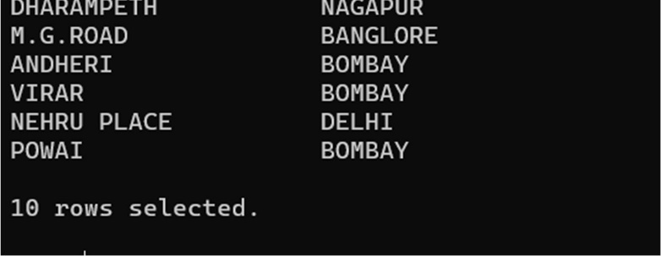

7. Give account no and amount of depositors.

Input:

select Act_no, Amount from Deposit;

Output:

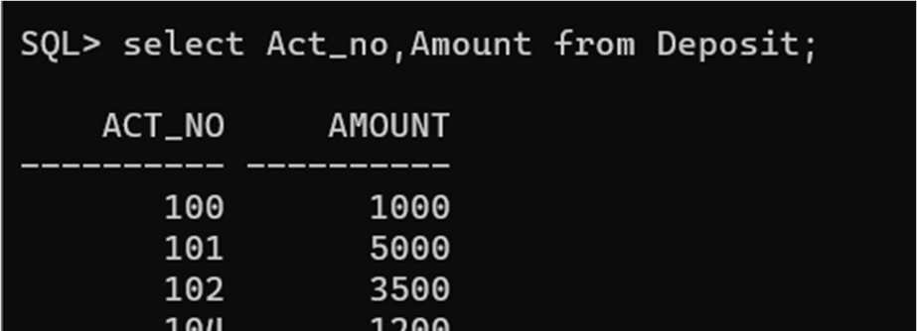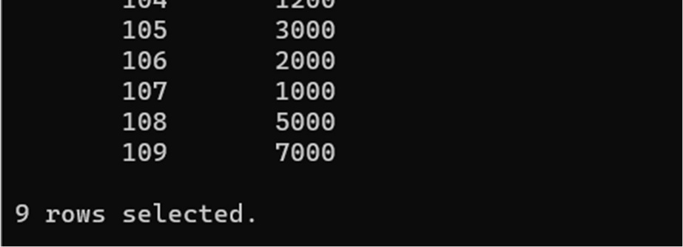

8. List all data from Sailors.

Input:

select *from Sailors;

Output:

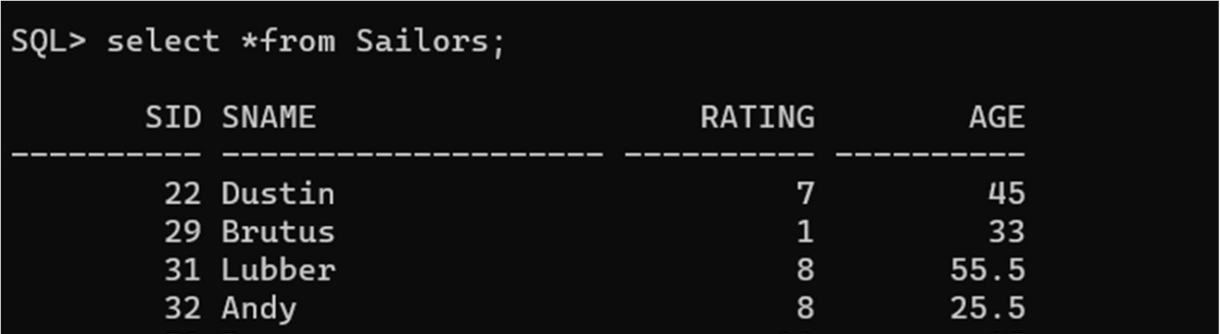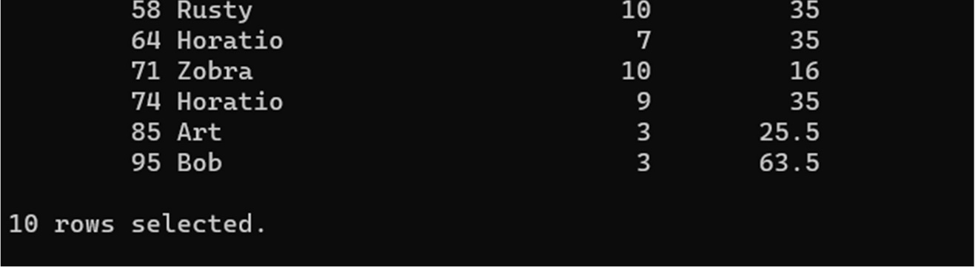

9. List Boat Name and its colour.

Input:

Select Bname and Color from Boats;

Output:

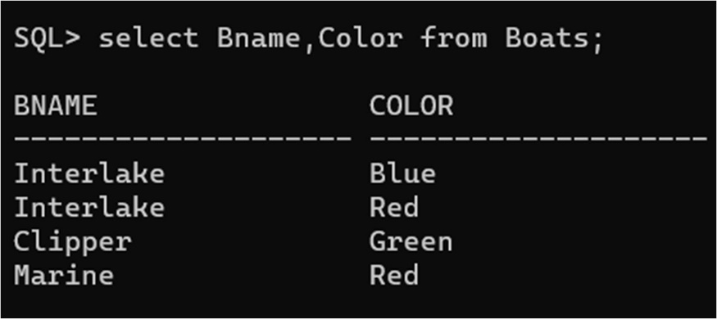

10. List Employee name and its City.

Input:

Select Emp_name, City from Employee;

Output:

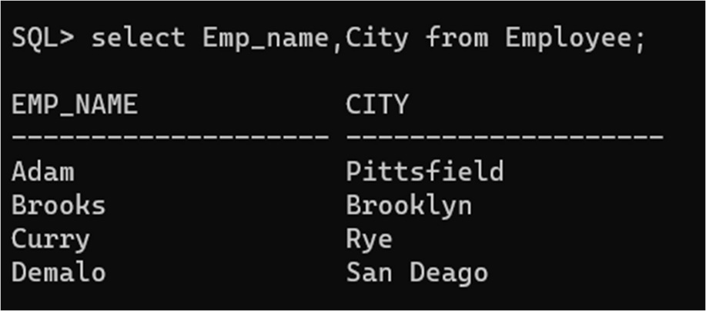

11. List all the details of Clients.

Input:

Select *from Client;

Output:

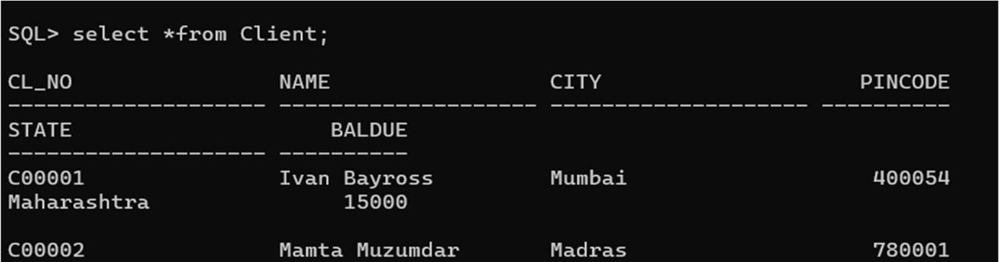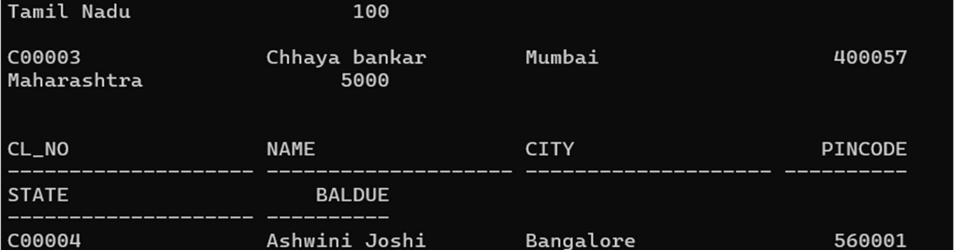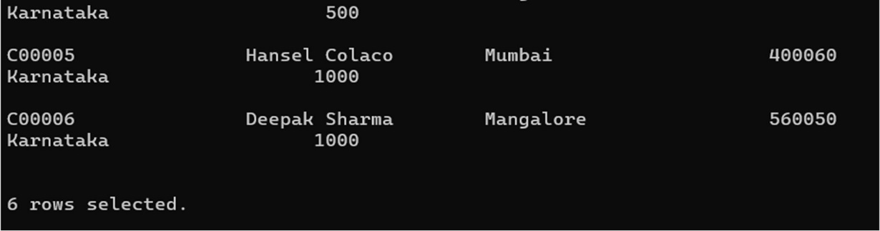

12. Describe various products and its price.

Input:

select DESC, Sell_price from Product;

Output:

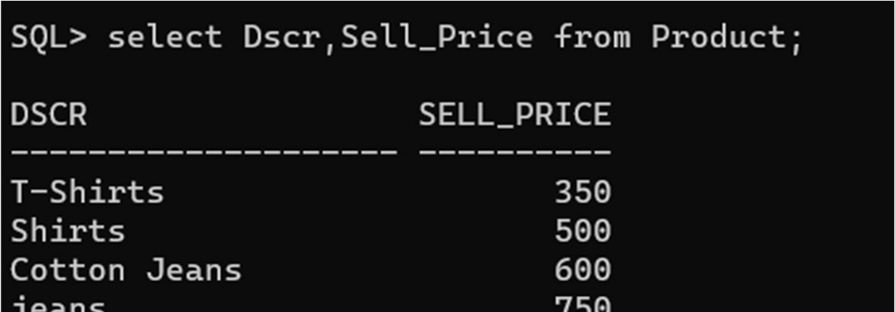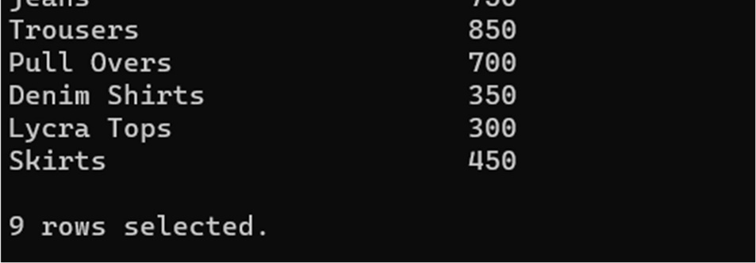

13. Describe Sailor’s name, age and its rating.

Input:

select Sname, Age, Rating from Sailors;

Output:

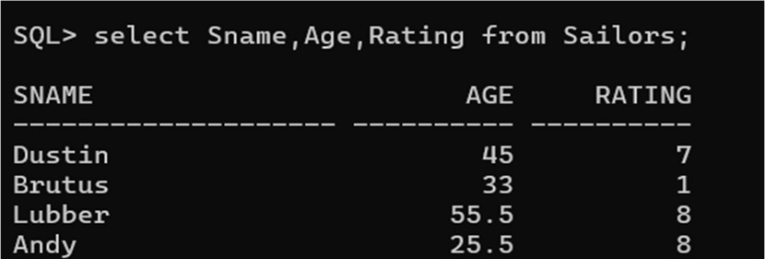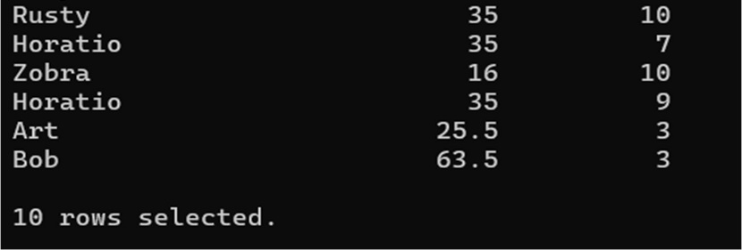

14. Describe the Managers of various employees.

Input:

select *from Manager;

Output:

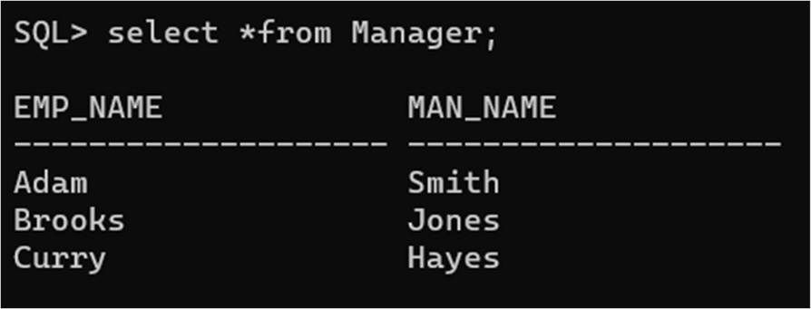

15. Describe the Details of Loan for Customers.

Input:

Select *from Borrow;

Output:

